Test Plan for
E-commerce API

General information
Customer | ECommerce API
Created by (Author) | Dishi Gogia
Preparation date | 20/06/2026
Version | V1.0

Revision History
Version | Description | Author | Date | Approved by
 |  |  |  | Author | Date
V1.0 | Test Plan – Draft 1 | Dishi Gogia | 20-06-2026

Summary
Table of Contents
Introduction 5
General information 5
Purpose 5
Scope of project 5
In-Scope 5
Out-Scope 6
Testing Lifecycle 6
Test Plan and Strategy 6
Test Procedure 7
Test Pyramid 7
Defect Management 8
Defect Lifecycle Diagram 8
Test Schedule 9
Resources 9
Tools 9
Supported Browsers 10
Resource Requirements 10
Test Estimation 10
Test Environment Diagram 11
Quality Criteria and Test Readiness 11
Entry Criteria 11
Exit Criteria 11
Testing Risks and Dependencies 11
Risks 11
Dependencies 12
Risk Assessment Matrix 12
Test Team Expectations 12
Roles and Responsibilities 13
Deliverables 13
Approval Section 13
Glossary of Terms 14
Supporting Documents 15

Introduction

General information

This document describes the methods, processes, and procedures that will be used by the QA team during the functional and non-functional testing of the application.

Testing will ensure that the application functions accurately, securely, and reliably across supported browsers, devices, environments, integrations, and network conditions.

This document serves as a guide for project managers, business stakeholders, developers, QA engineers, UAT participants, and release managers throughout the testing lifecycle.

The QA strategy follows a risk-based approach, where critical business workflows and high-impact functionalities are prioritized first. Special focus will be given to validating business processes, integrations, APIs, user roles, security, performance, and overall user experience.

Purpose

This Test Plan document defines the testing approach, scope, objectives, resources, and deliverables for Manual API Testing of an E-Commerce Application using Postman.

The primary objective of this testing effort is to validate the functionality, reliability, and correctness of the exposed REST APIs and ensure that critical e-commerce business workflows operate as expected.

This Test Plan supports the following objectives:
• Validate product catalog, user management, cart management, authentication, category management, and search functionalities.
• Verify request and response data integrity.
• Validate business workflows across multiple APIs.
• Perform positive and negative testing scenarios.
• Validate status codes, response structures, and response headers.
• Verify API reliability and business rule enforcement.
• Identify defects and functional gaps before release.

Scope of project

In-Scope

- Authentication APIs
- Product APIs
- Category APIs
- Cart APIs
- User APIs
- Search APIs
- Order APIs
- Pagination Validation
- Schema Validation
- Response Time Validation
- Negative Testing
- Status Code Validation
- Response Validation
- Header Validation
- JWT Token Validation
- Authorization Testing
- Role Based Access Validation

Out-Scope

- UI Testing
- Performance Testing
- Automation Testing
- Security Testing
- Database Testing

Testing Lifecycle

The parties agreed to follow the next work plan:
Phase | Key Activities
Planning | Requirement review, scope analysis, test strategy creation
Preparation | Test case design, test data setup, environment readiness
Execution | Functional, integration, API, regression, and exploratory testing
Defect Management | Defect logging, retesting, triage, and reporting
Closure | Final reporting, lessons learned, sign-off, and release readiness

Test Plan and Strategy

The testing approach for the project will follow a risk-based and business-critical strategy to ensure that the most important user journeys and core business workflows are validated first.
Testing will focus on both functional and non-functional areas to ensure that the application is stable, secure, scalable, and user-friendly across supported platforms and environments.
The following testing types will be included as part of the overall QA strategy:

Testing Type | Objective | Example Coverage
Functional Testing | Validate business workflows | Login, search, checkout
System Testing | Validate end-to-end flows | Multi-step business scenarios
Integration Testing | Validate external systems | APIs, payment gateways
API / Service Layer Testing | Validate requests and responses | Status codes, payload validation
Regression Testing | Ensure no impact from changes | Existing core workflows
Smoke Testing | Confirm build stability | Basic login and navigation
UAT Support | Support business validation | UAT issue resolution

Test Procedure
Testing activities will include functional, system, integration, API, regression, and UAT validation.

Additional exploratory, negative, boundary, and end-to-end testing will be performed for high-risk business workflows and critical user journeys.

Testing will validate business rules, data accuracy, integrations, user roles, security controls, workflows, calculations, notifications, and reporting functionality.

The application will also be validated across supported browsers, devices, operating systems, and environments to ensure consistent behavior and compatibility.

Defects identified during testing will be logged with supporting evidence, prioritized based on severity and business impact, and retested once fixes are delivered.

Regression testing will be performed for every major build and release cycle to ensure that new changes do not impact existing functionality.

Test Pyramid

The test pyramid emphasizes a balanced testing approach with a larger focus on unit and API testing, supported by a smaller number of UI and end-to-end tests.
• Bottom Layer: Unit / Component Tests
These tests validate individual functions, methods, classes, and components. They are fast, stable, and provide the highest coverage with the lowest maintenance effort.
• Middle Layer: API / Integration Tests
These tests validate interfaces, APIs, services, databases, and integrations between systems. They provide strong business coverage while remaining faster and more stable than UI tests.
• Top Layer: UI / End-to-End Tests
These tests validate complete user journeys and business workflows through the user interface. They are important for business-critical flows but should be limited because they are slower, more fragile, and require higher maintenance effort.

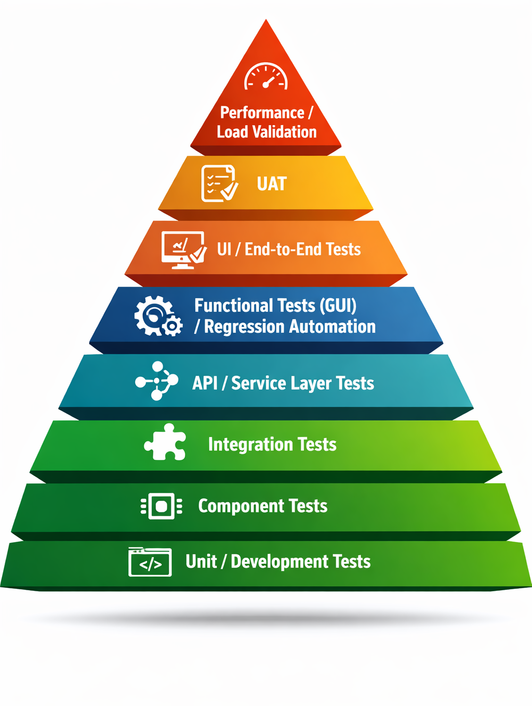

Defect Management

Defects should be logged with clear reproduction steps, expected results, actual results, severity, priority, screenshots, environment details, and supporting evidence.

Bug reports should provide the development team and stakeholders with sufficient information to understand, reproduce, and resolve the issue.

Defect severity can be classified into four categories:
• Critical – Complete system failure or a blocker that prevents further testing or usage.
• High – Significant functionality issue where part of the system fails, but workarounds may exist.
• Medium – Issue that does not block functionality but causes incorrect or inconsistent behavior.
• Low – Cosmetic or low-impact issue such as typos, formatting, or minor UI inconsistencies.

Each bug report should include:
• Defect summary
• Module or feature impacted
• Steps to reproduce
• Expected result
• Actual result
• Severity and priority
• Environment details
• Browser / device information
• Frequency of occurrence
• Screenshots, logs, or video evidence

All defects will be tracked and managed using the approved defect management tool throughout the testing lifecycle.

Defect Lifecycle Diagram

The following defect lifecycle shows how issues are managed from identification through closure, including alternate paths for rejected, duplicate, or non-reproducible defects.
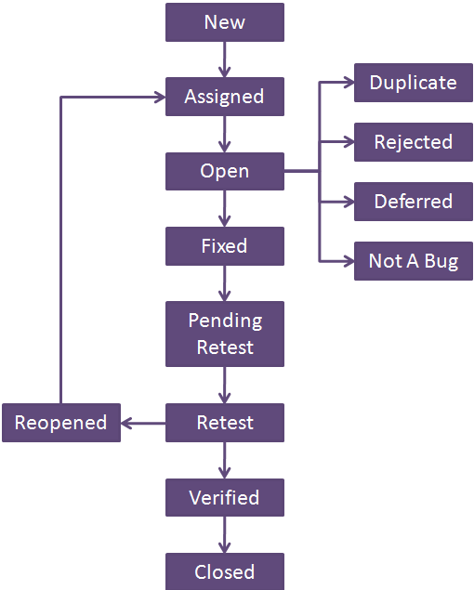

Test Schedule

Phase | Duration | Key Activities
Week 1 | Planning | Requirement review, test planning, estimation
Week 2 | Preparation | Test case creation, test data setup
Week 3 | Environment Readiness | Build deployment, smoke validation
Week 4–5 | Test Execution | Functional, API, integration testing
Week 6 | Regression & Retesting | Defect retesting
Week 7 | UAT Support | Business validation, issue resolution
Week 8 | Closure | Final reporting, sign-off, release readiness

Resources

Tools

The following tools will be used for the project:
Process Area | Tool | Purpose
Defect Tracking | Azure DevOps / Jira | Log and manage defects
Test Case Management | Azure DevOps / Jira | Manage test cases and execution
API Testing | Postman | Validate APIs and services
Screenshots / Video Capture | Snagit | Capture evidence and recordings

Resource Requirements

Resource / Requirement | Purpose / Usage
QA Engineers | Execute test cases and validate functionality
QA Lead / QA Manager | Drive strategy, reporting, and release readiness
Test Environment Access | Required for execution and validation
Test Data | Required for business scenario coverage
Browsers and Devices | Needed for compatibility validation
API Access and Test Accounts | Required for service testing
Defect Tracking and Test Management Tools | Required for defect logging and reporting

Test Estimation

The following effort estimates provide a high-level view of testing effort across major QA activities.

Activity | Estimated Effort
Requirement Analysis | 5 person-days
Test Planning | 3 person-days
Test Case Design | 15 person-days
Test Execution | 25 person-days
Defect Retesting | 10 person-days
Regression Testing | 8 person-days
Reporting and Closure | 4 person-days

Test Environment Diagram

The following environment flow illustrates how builds move across different testing stages
before production deployment. Each environment should contain the required test data, user accounts, integrations, and access permissions needed for execution.

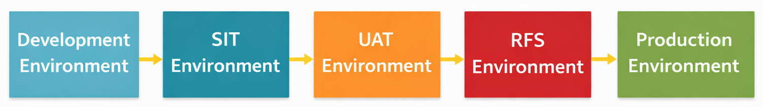

Quality Criteria and Test Readiness

Entry Criteria
The following conditions must be met before testing begins:
• Requirements are reviewed and approved
• Test environment is available and stable
• Test data is prepared
• API endpoints are accessible.
• Postman is installed
• API Gateway Access
• Authentication Credentials
• Test Data
• Environment URLs
• Build is deployed successfully
• Required tools and access are available
• Test cases are reviewed and approved

Exit Criteria
The following conditions must be met before testing is considered complete:
• All planned test cases are executed
• Critical and high-severity defects are closed
• Regression testing is completed
• Stakeholders have reviewed testing status
• Release readiness checklist is completed
• Go / No-Go recommendation is provided
• Test summary report completed.

Testing Risks and Dependencies

Risks

Risk | Potential Impact | Mitigation
Frequent requirement changes | Scope creep and retesting | Frequent requirement reviews
Delayed stable builds | Execution delays | Close coordination with development team
Third-party system dependency | Blocked integration testing | Mock services and fallback validation
Environment instability | Execution delays | Backup environments and contingency plans
Public API downtime | Execution delays | Retest later
Delayed stakeholder feedback | UAT delays | Early planning and checkpoints

Dependencies

Dependency | Reason | Impact if Delayed
Stable test environments | Required for execution | Delays in testing start
Test data availability | Required for business scenarios | Reduced coverage
Development build delivery | Needed for execution | Delayed defect identification
Third-party system availability | Needed for integrations | Blocked end-to-end testing
Stakeholder availability | Needed for UAT and approvals | Delayed sign-off

Risk Assessment Matrix

The following matrix highlights the probability, business impact, and mitigation approach for key testing risks.

Risk | Probability | Impact | Severity | Mitigation
Environment instability | High | High | Critical | Backup environment and contingency planning
Delayed build delivery | Medium | High | High | Frequent coordination with development team
Third-party system downtime | Medium | Medium | Medium | Use mock services and fallback testing
Test data unavailability | Medium | Medium | Medium | Prepare reusable test datasets
UAT delays | Low | High | Medium | Early stakeholder alignment

Test Team Expectations

The test team is expected to maintain clear communication, timely defect reporting, proactive risk identification, and close collaboration with business and development teams throughout the testing lifecycle.
• Updated requirements, designs, and supporting documents should be shared throughout the testing lifecycle
• All required environments, devices, tools, access, and test data should be prepared before testing begins
• Critical and blocker defects should be prioritized and resolved as quickly as possible
• Release notes should be shared with each build to explain new features, enhancements, bug fixes, and known issues
• Development teams should ensure that major defects are resolved and validated before providing a new build for testing
• Stakeholders should be available for requirement clarification, defect triage, and UAT support when needed
• Risks, dependencies, and blockers should be escalated early to avoid delays in execution and release timelines

Roles and Responsibilities

The following roles are responsible for planning, execution, reporting, stakeholder communication, and release readiness activities.

Role | Responsibilities
Project Manager | Manage schedule, scope, resources, and communication
QA Lead / QA Manager | Define strategy, estimation, risk, and reporting
QA Engineer | Execute tests, log defects, support regression
Business User | Validate business workflows and UAT scenarios
Development Team | Fix defects and support technical clarifications

Deliverables

The following deliverables are expected throughout the testing lifecycle to support execution, reporting, traceability, and release readiness.

Deliverable | Description | Owner / Audience
Test Plan | Defines strategy, scope, and resources | QA Lead / Stakeholders
Test Cases | Detailed scenarios and expected results | QA Team
Defect Reports | Captured issues and evidence | QA Team / Development Team
Test Execution Report | Summary of execution progress | QA Lead / Stakeholders
Release Readiness Checklist | Go / No-Go readiness status | QA Lead / Project Team
Test Closure Report | Final summary of testing outcomes | QA Lead / Leadership

Approval Section

Role | Name | Sign-Off Status
Project Manager
QA Lead
Business Owner
Product Owner
Development Manager
Business Analyst Manager

Glossary of Terms

The glossary of terms provides a list of definitions for key terms and acronyms used throughout the API test plan.
Term | Definition
Issue | A defect, gap, or deviation from expected behaviour identified during testing.
Impact | The level of effect an issue has on the system, business process, or user experience.
Priority | The level of importance assigned to a defect based on business impact and urgency.
Regression Testing | Testing performed to ensure that existing functionality is not negatively affected by new changes or fixes.
Stakeholder | Any individual, team, or business group involved in or affected by the project.
Test Environment | The setup of hardware, software, network, configurations, and integrations used for testing.
Test Case | A detailed set of steps, data, and expected results used to validate a specific scenario.
Test Coverage | The extent to which business requirements, workflows, and features are validated during testing.
Test Data | The sample data, user accounts, or datasets used during test execution.
Test Execution | The process of running test cases, recording results, and identifying defects.
Test Plan | A document that defines the scope, objectives, approach, schedule, and resources for testing.
Test Scenario | A high-level business flow or use case to be validated during testing.
UAT | User Acceptance Testing. The phase where business users validate that the system is ready for production use.
UAT Sign-Off | Formal approval from business users and stakeholders indicating acceptance of the system.
Defect Severity | The level of impact a defect has on the application or business process.
Defect Priority | The urgency with which a defect should be resolved.
Business User | An end user or stakeholder who validates business workflows during UAT.
Go / No-Go Decision | A decision made by stakeholders on whether the application is ready for production release.
Test Closure | The final stage of testing where results, defects, lessons learned, and sign-off are completed.

Supporting Documents

This section lists the supporting documents and references relevant to the overall testing
lifecycle.
Supporting Document | Purpose
Business Requirements | Defines business needs and objectives
Functional Requirements | Defines detailed system behaviour
Solution Design Document | Describes architecture and integrations
Test Cases | Defines detailed test scenarios
Test Data | Provides required datasets and accounts
Release Notes | Summarizes new features and fixes
UAT Sign-Off Document | Captures business approval

